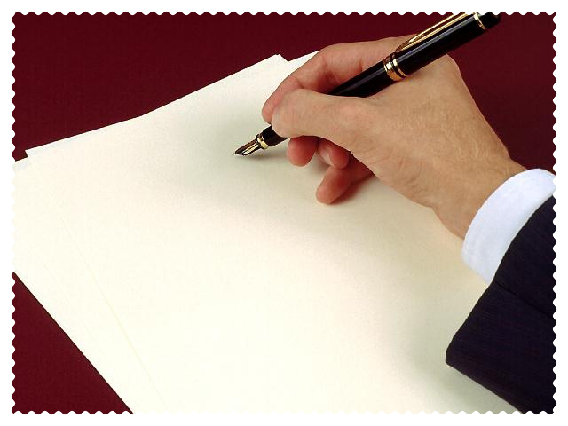

The Letter

Proper penmanship is key to clear communication and to presenting an intelligent image of yourself and/or the ministry you represent. People make automatic judgments about others simply based on how they write. If you want your writing to paint a positive image of yourself in the minds of your readers, then you must take great care in developing good penmanship.

Haste makes waste.

Take your time when writing to do it right. Anything worth doing is worth doing well. Too often we get in a hurry when writing for absolutely no reason at all.
Developing good penmanship takes time. Steadiness and consistency are possible only through developing good habits when writing. When taking notes in church don’t be so rushed. When studying, don’t be quick to just scratch it down. Your writing is important; so, slow down and write!

Poor penmanship sends certain messages to the reader:

- The writer does not think his writing is all that important. Why should I?
- The writer wrote in a hurry; so, I will read in a hurry and probably just scan through the paper.
- Not too much time was taken to write this paper; therefore, it must not be very valuable.
- The writer must not think I am very important, or he would have written more neatly.
- This paper must be just a rough draft; I won’t even bother reading it. I will read it when it is finished.
- The writer doesn’t know how to write; therefore, he must not know what he is writing about either. I don’t care to read what they have written.

Write in such a way that your penmanship could be described with the following adjectives:

- neat
- sharp
- clear
- professional

In conclusion, good penmanship essentially strengthens two areas:

- IMAGE – Paints a picture in the readers mind of what kind of person you are, or what kind of ministry you represent, as well as, what kind of person you think your readers are.

- VALUE – Neatness and professional appearance increase the value of your writing. Good handwriting gains the respect of your readers and adds verity to the content of your writing.

If you want to be taken serious and what you write to be deemed valuable, then take great care in developing good penmanship.

